LO | The Learning Objective is at the top of my page so I know what I am learning about.
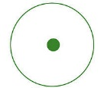 | I need to use full stops
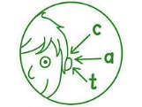 | I need to use my phonics to help me spell words
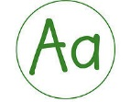 | I need to use capital letters
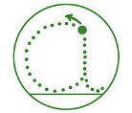 | I need to form my letters correctly
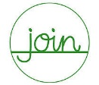 | I need to join my handwriting
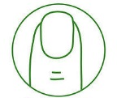 | I need to use finger spaces
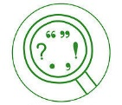 | I need to use punctuation correctly
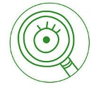 | I need to proof read my work
VF | Verbal Feedback from an adult to help me improve my work
sp  (underline the word) | I have a spelling mistake to correct. I copy it three times.
Other symbols my teacher may use. | Good example ? I need to check if this makes sense  O I have a mistake to correct I need to add something to my work
SA | Self Assessment of my work
PA | Peer Assessment of my work
Green Polishing Pen | I respond to comments and edit my work in green pen

