LO | The Learning Objective is at the top of my page so I know what I am learning about
 | Correct answer
 | A mistake that needs to be corrected
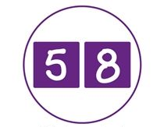 | I need to write one number per square
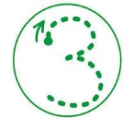 | I need to form my numbers correctly
C Target | A target to challenge me
sp  (underline the word) | I have a spelling mistake to correct. I copy these three times at the end of my work so I don’t forget!
VF | Verbal Feedback from an adult to help me improve my work
SA | Self Assessment of my work
PA | Peer Assessment of my work
Green Polishing Pen | I respond to comments and edit my work in green pen

