LO | The Learning Objective is at the top of my page so I know what I am learning about.
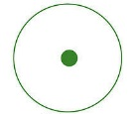 | I need to use full stops
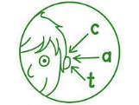 | I need to use my phonics to help me spell words
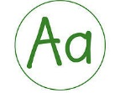 | I need to use capital letters
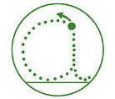 | I need to form my letters correctly
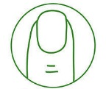 | I need to use finger spaces
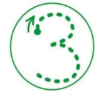 | I need to form my numbers correctly
 | Good Work!
VF | Verbal Feedback from an adult to help me improve my work
AS | An adult has supported my learning

