PARSLOES PRIMARY SCHOOL

Display Policy

Approved by Governing Body: October 2020

L. Pearce (Head Teacher)

R. Hunter (Chair of Governors / Designated Safeguarding Governor)

DISPLAY POLICY

RATIONALE
Display supports, promotes and celebrates learning and can be particularly helpful for visual learners. Effective displays should enhance and enrich the quality of our learning environments and offers opportunities to increase learning skills. Displaying children’s work celebrates and acknowledges their achievements and reflects our shared community.

AIMS
Displays should:
- be bright, stimulating, promote discussion and welcome children, parents, staff and visitors
- celebrate children’s achievements, boost self-esteem and confidence, as well as show value of work and learning in all areas of the curriculum
- be an interactive resource to support teaching, learning and assessment effectively and will enable children, parents, staff and visitors to gain an insight into the activities being undertaken throughout the school
- develop children’s ownership through their involvement in the development of their working environment, giving credence and respect for their decisions by having the opportunity to display their own work
- positively impact on learning through consolidation, be a reminder of previous learning and introduce new information and knowledge
- encourage positive evaluation and mutual respect of art, craft and design work by both children and adults
- ensure that all pupils have the opportunity to have their work included as part of a high-quality display, regardless of their individual ability, that recognises their personal achievements

HEALTH AND SAFETY
Staff should ensure that:
- all resources are used correctly for their own and the children’s safety
- children do not use staple guns
- step ladders and kick-stools are used correctly in order to access displays that are out of easy reach
- displays are safe, e.g. staples or pins do not stick out so that they could cause injury; items are not likely to fall from displays; displays do not affect the safe function of lights or alarm systems

DISPLAY GUIDELINES
Staff should ensure that:
- staples should be stapled in at an angle for ease of getting them out completely on walls when displays are changed.
- all work will be labelled using a consistent size and style of type/letter form, and a consistent colour of paper/card on each display as appropriate
- children's work should be clearly named using initials or first name only, using an appropriate, consistent method for each display
- display boards are backed in bright primary or secondary colours. Pastel versions of these colours should only be used as backing when it is appropriate to the theme of the board, e.g. pastel blue to represent the sky
- corridor displays should have a title and will include explanatory labels to inform the viewer of year group, class, subject, topic of display work and will explain the process undertaken by the children as necessary
- displays include reinforcement of key vocabulary, where appropriate
- children’s work should be mounted, except where it would detract from the work, and trimmed evenly and neatly
- displays with children’s work on, should not be marked
- there should be a balance of 2D and 3D work, according to space available
- displays should be creative and websites such as Twinkl should not be used to create complete displays, except the display lettering if appropriate

CLASSROOM DISPLAYS
In classrooms the staff should ensure that the following is in place:

- Talk4Writing, including a washing line (please see Appendices for how this should look)
- Handwriting
- Maths Working Wall (should be up-to-date with the current teaching, including examples of methods and vocabulary)
- Topic (changed with each topic taught)
- British Values
- Stay on Green
- House Point Charts
- Book Corner

MONITORING POLICY
The policy will be monitored and evaluated by Subject Leads, Curriculum Leads, all staff.

Photographs should be taken of effective displays to be used as a guide for future displays.

Appendix A: English Working Wall

- The working wall should be split into three parts – core vocabulary, sentence patterns and WAGOLL (What a Good One Looks Like). Signs and the picture of the magpie are provided.
- Vocabulary and sentence patterns should be handwritten by the teacher, modelling school script.
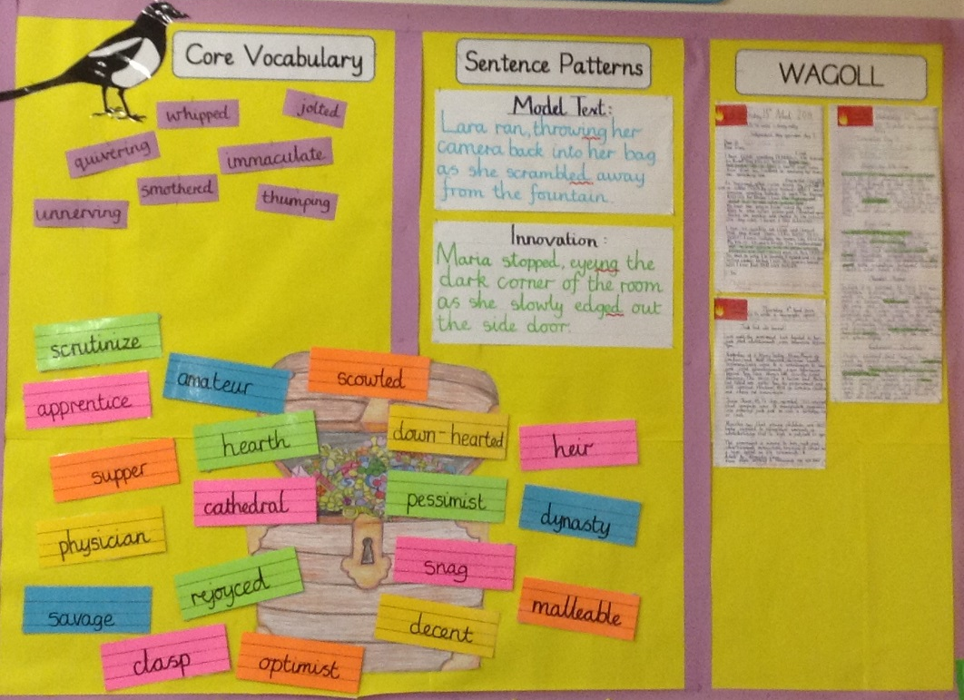

Appendix B: Washing Line
- The washing line should start with the everyday writing toolkit for your year group.
- After this, it will show the Talk4Writing ‘journey’ in chronological order.
- All writing should be handwritten on flipchart paper modelling school script.
- Shared writing should be completed on the Talk4Writing flipchart pad.
- No sugar paper should be on the washing line.
- The following elements should be included on the washing line. Try to avoid over-reliance on grammar elements.
  - Text map
  - Vocabulary development
  - Reading as a Reader
  - Toolkit
  - Boxing up
  - Shared writing section by section

