Overview of Texts
 |  | Autumn 1 | Autumn 2 | Spring 1 | Spring 2 |  | Summer 1 | Summer 2
N | Talk4Writing | Selection of Nursery Rhymes | Brown Bear, Brown Bear, What Do You See? – Bill Martin Jr | The Little Red Hen – Carol Ottolenghi | Stuck in the Mud – Pie Corbett |  | Mr Wiggle and Mr Waggle – Pie Corbett | The Three Billy Goats Gruff – Mara Alperin
 | Topic | Incredible Me! | I Can See A Rainbow | Inside Out! | Ready, Steady, Go! |  | How Does Your Garden Grow? | There’s No Place Like Home
 | Reading Spine | Where’s Spot? – Eric Hill Dear Zoo – Rod Campbell We’re Going on a Bear Hunt – Michael Rosen  You Choose – Nick Sharratt The Very Hungry Caterpillar – Eric Carle Hairy Maclary from Donaldson’s Dairy – Lynley Dodd  Each Peach Pear Plum – Alan Ahlberg The Train Ride – June Crebbin Come on Daisy! – Jane Simmons  Hug – Jez Alborough
R | Talk4Writing | Baby Mouse – Pie Corbett | Take a Walk Little Bear – Pie Corbett | Sleepy Bumble Bee – Pie Corbett | The Gingerbread Man – Mara Alperin |  | Farmer Duck – Martin Waddell | The Three Little Pigs – Mara Alperin
 | Topic | Superheroes! | Teddy Bear’s Picnic | It’s a Bug’s Life! | Once Upon a Time.. |  | Down on the Farm | Eco-Warriors!
 | Guided Reading | Selection of appropriate decodable texts
 | Reading Spine | Owl Babies – Martin Waddell Mr Gumpy’s Outing – John Burningham Rosie’s Walk – Pat Hutchins  Six Dinner Sid – Inga Moore Mrs Armitage – Quentin Blake Whatever Next – Jill Murphy  On the Way Home – Jill Murphy Shhh! – Sally Grindley Goodnight Moon – Margaret Wise Brown
Y1 | Talk4Writing | The Gigantic Turnip – Aleksei Tolstoy | How to Catch a Star – Oliver Jeffers | Handa’s Surprise – Eileen Browne  Handa’s Hen – Eileen Browne | Cinderella – Ladybird First Favourite Tales  If I Had Wings – Pie Corbett |  | The Storm Whale – Benji Davis  Dear Greenpeace - Simon James  Big Blue Whale – Nicola Davis | The Gruffalo – Julia Donaldson  The Big Big Sea – Martin Waddell
 | Topic | What’s in the Toybox?  Old Bear – Jane Hissey | Sparkle and Shine  How to Catch a Star – Oliver Jeffers | Sensational!  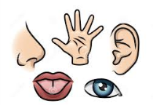  Handa’s Surprise – Eileen Browne | This is Me!  Elmer – David McKee |  | Time for Tea  The Tiger Who Came to Tea – Judith Kerr | Oh Help! Oh No! It’s a Gruffalo  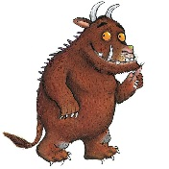  The Gruffalo – Julia Donaldson
 | Guided Reading | Selection of appropriate decodable texts
 | Reading Spine | Peace at Last – Jill Murphy Can’t You Sleep Little Bear? – Martin Waddell The Elephant and the Bad Baby – Raymond Briggs  Avocado Baby – John Burningham Lost and Found – Oliver Jeffers Knuffle Bunny – Mo Willems  Beegu – Alexis Deacon Dogger – Shirley Hughes Cops and Robbers – Alan Ahlberg
Y2 | Talk4Writing | Meerkat Mail – Emily Gravett | Katie in London – James Mayhew | The Owl Who Was Afraid of the Dark – Jill Tomlinson | Supertato – Sue Hendra |  | The Selfish Giant – Oscar Wilde | Traction Man is Here! – Mini Grey
 | Topic | What a Wonderful World!  Meerkat Mail – Emily Gravett | London’s Calling  Katie in London – James Mayhew | If You Go Down To The Woods Today…  The Owl Who Was Afraid of the Dark – Jill Tomlinson | Amazing Me  Amazing Grace – Mary Hoffman |  | Blooming Marvellous  The Selfish Giant – Oscar Wilde | Eureka!  Traction Man is Here! – Mini Grey
 | Guided Reading | Selection of appropriate decodable texts
 | Reading Spine | Pumpkin Soup – Helen Cooper Who’s Afraid of the Big Bad Book? – Lauren Child Dr Xargle’s Book of Earthlets – Tony Ross  Not Now Bernard – David McKee Tuesday – David Weisner The Flower – John Light  Gorilla – Anthony Browne Emily Brown and the Thing – Cressida Cowell Frog and Toad Together – Arnold Lobel  Fantastic Mr Fox – Roald Dahl The Giraffe, the Pelly & Me – Roald Dahl The Hodgeheg – Dick King-Smith  Flat Stanley – Jeff Brown Willa and Old Miss Annie – Berlie Doherty
Y3 | Talk4Writing | Otherwise (BFI short film)  The Magic Box – Kit Wright | Stone Age Boy – Satoshi Kitamura | Cloudy With a Chance of Meatballs – Judi Barrett |  | Gregory Cool – Caroline Binch | The Story of Tutankhamun – Patricia Cleveland-Peck  The Sound Collector – Roger McGough | The Iron Man – Ted Hughes
 | Topic / Guided Reading | Deep in the Jungle  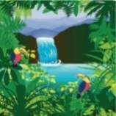  The Jungle Book – Ladybird Classics  Otherwise (BFI short film) | Stone Age Detectives  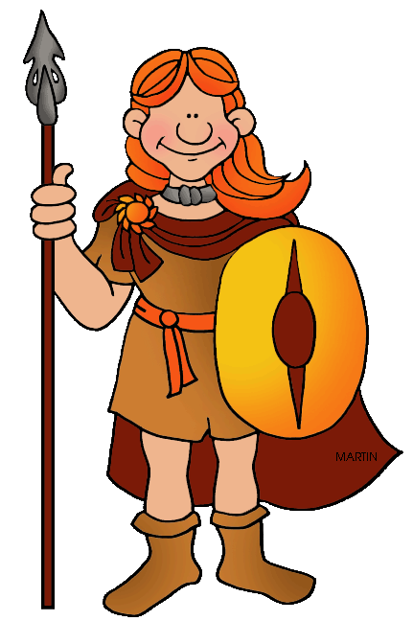  Stone Age Boy – Satoshi Kitamura  The Pebble in My Pocket – Meredith Hooper | Come Dine With Us  Cloudy With a Chance of Meatballs – Judi Barrett  Lunchbox: The Story of Your Food – Chris Butterworth | Totally Tropical  Gregory Cool – Caroline Binch |  | Tombs and Treasure  Egyptian Cinderella – Shirley Climo  The Story of Tutankhamun – Patricia Cleveland-Peck | Feel the Force  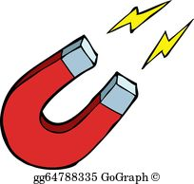  Iron Man – Ted Hughes
 | Reading Spine | The Sheep-Pig – Dick King-Smith The Abominables – Dick King-Smith  The Battle of Bubble and Squeak – Philipa Pearce Hansel and Gretel – Anthony Browne  The Lion, The Witch and the Wardrobe – C.S. Lewis
Y4 | Talk4 Writing | Charlie and the Chocolate Factory – Roald Dahl | I Believe in Unicorns – Michael Morpurgo | Persephone – Sally Pomme Clayton | The True Story of the Three Little Pigs – Jon Scieszka  The Wolf’s Story – Izhar Cohen |  | Bill’s New Frock – Anne Fine | Escape from Pompeii – Christina Balit
 | Topic | Truly Scrumptious  Charlie and the Chocolate Factory – Roald Dahl | I Believe in Unicorns  I Believe in Unicorns – Michael Morpurgo | It’s All Greek to Me!  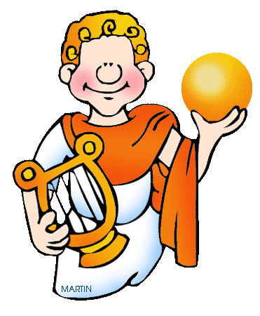  Persephone – Sally Pomme Clayton  Theseus and the Minotaur – Jane Ray | Bright Lights, Big City  When Jessie Came Across the Sea – Amy Hest  Here I Am – Patti Kim |  | Strike a Pose  Bill’s New Frock – Anne Fine | When In Rome..  Escape from Pompeii – Christina Balit  When the Giant Stirred – Celia Godkin
 | Reading Spine | Why the Whales Came – Michael Morpurgo The Firework Maker’s Daughter – Philip Pullman  The Snow Walker’s Son – Catherine Fisher Perry Angel’s Suitcase – Glenda Millard  Voices in the Park – Anthony Browne
Y5 | Talk4Writing | Macbeth – Andrew Matthews | Beowulf – Michael Morpurgo | Clockwork – Philip Pullman  The Highway Man – Alfred Noyes | Charlotte’s Web – E.B. White |  | Mufaro’s Beautiful Daughters – John Steptoe | The Jamie Drake Equation – Christopher Edge
 | Topic / Guided Reading | Is That London I See Before Me?  Macbeth – Andrew Matthews  London – Simon Holland | Raiders and Rulers  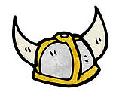  Beowulf – Michael Morpurgo | Use the Force!  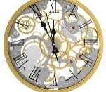  Clockwork – Philip Pullman | The Circle of Life  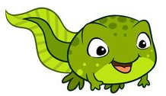  Charlotte’s Web – E.B. White  Tadpole’s Promise – Jeanne Willis |  | Into Africa  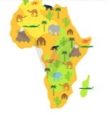  Mufaro’s Beautiful Daughters – John Steptoe  One Hen – Katie Smith Milway | To Infinity and Beyond  The Jamie Drake Equation – Christopher Edge
 | Reading Spine | The Wolves of Willoughby Chase – Joan Aiken Varjak Paw – SF Said  Wolf Brother – Michelle Paver Street Child – Berlie Doherty  The Midnight Fox – Betsy Byars Tom’s Midnight Garden – Philippa Pearce  FArTHER – Grahame Baker-Smith
Y6 | Talk4Writing | Flotsam – David Weisner  Tree of Life – Rachel Strauss | Stay Where You Are and Then Leave – John Boyne | Stormbreaker – Anthony Horowitz |  | The Lighthouse (short film) | What Mr Darwin Saw – Mick Manning | Matilda – Roald Dahl
 | Topic / Guided Reading | Natural World  Flotsam – David Weisner  Tree of Life – Rachel Strauss  Deadly! – Nicola Davies | The Great War  Stay Where You Are and Then Leave – John Boyne  Archie’s War – Marcia Williams | The Future is Bright  Stormbreaker – Anthony Horowitz |  | Castaway  Kensuke’s Kingdom – Michael Morpurgo  What Mr Darwin Saw – Mick Manning |  | Making Memories  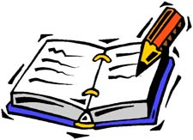  Matilda – Roald Dahl
 | Reading Spine | Holes – Louis Sachar The Hobbit – JRR Tolkein Skellig – David Almond  Fireweed – Jill Paton Walsh River Boy – Tim Bowler The Arrival – Shaun Tan

