Parsloes Primary School
Key Stage 2 Curriculum Map
Year 3
 | Autumn 1 | Autumn 2 | Spring 1 | Spring 2 | Summer 1 | Summer 2
Unit | Deep in The Jungle  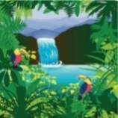 | Stone Age Detectives  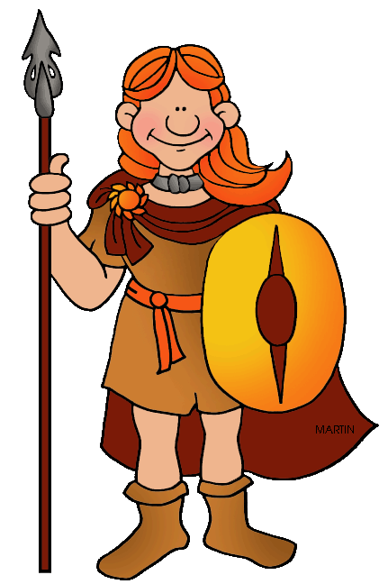 | Come Dine With Us | Totally Tropical | Tombs and Treasure  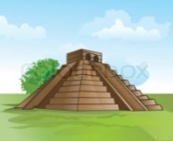 | Feel the Force  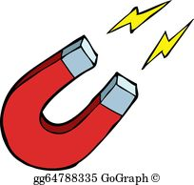
Year 4
 | Autumn 1 | Autumn 2 | Spring 1 | Spring 2 | Summer 1 | Summer 2
Unit | Truly Scrumptious | I Believe in Unicorns | It’s All Greek To Me!  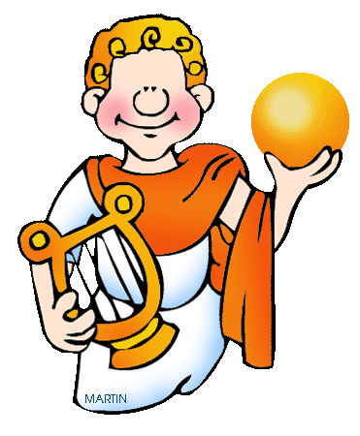 | Bright Lights, Big City | Strike a Pose | When In Rome…
Year 5
 | Autumn 1 | Autumn 2 | Spring 1 | Spring 2 | Summer 1 | Summer 2
Unit | Is that London I see before me? | Raiders and Rulers | Use the Force! | The Circle of Life  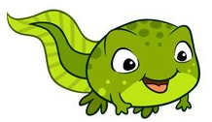 | Into Africa  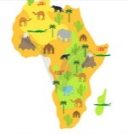 | To Infinity and Beyond
Year 6
 | Autumn 1 | Autumn 2 | Spring 1 | Spring 2 | Summer 1 | Summer 2
Unit | Natural World | The Great War | The Future is Bright | Castaway |  | Making Memories

