Parsloes Primary School
Key Stage 1 Curriculum Map

Year 1
 | Autumn 1 | Autumn 2 | Spring 1 | Spring 2 | Summer 1 | Summer 2
Unit | What’s In The Toybox? | Sparkle and Shine | Sensational!  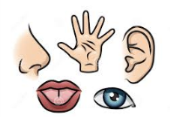 | This is Me! | Time for Tea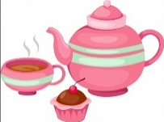 | Oh Help! Oh No! It’s a Gruffalo!  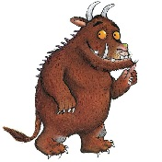

Year 2
 | Autumn 1 | Autumn 2 | Spring 1 | Spring 2 | Summer 1 | Summer 2
Unit | What a Wonderful World | London’s Calling | If You Go Down To The Woods Today… | Amazing Me! | Blooming Marvellous | Eureka!

