**Parsloes Press**

**House Challenge**

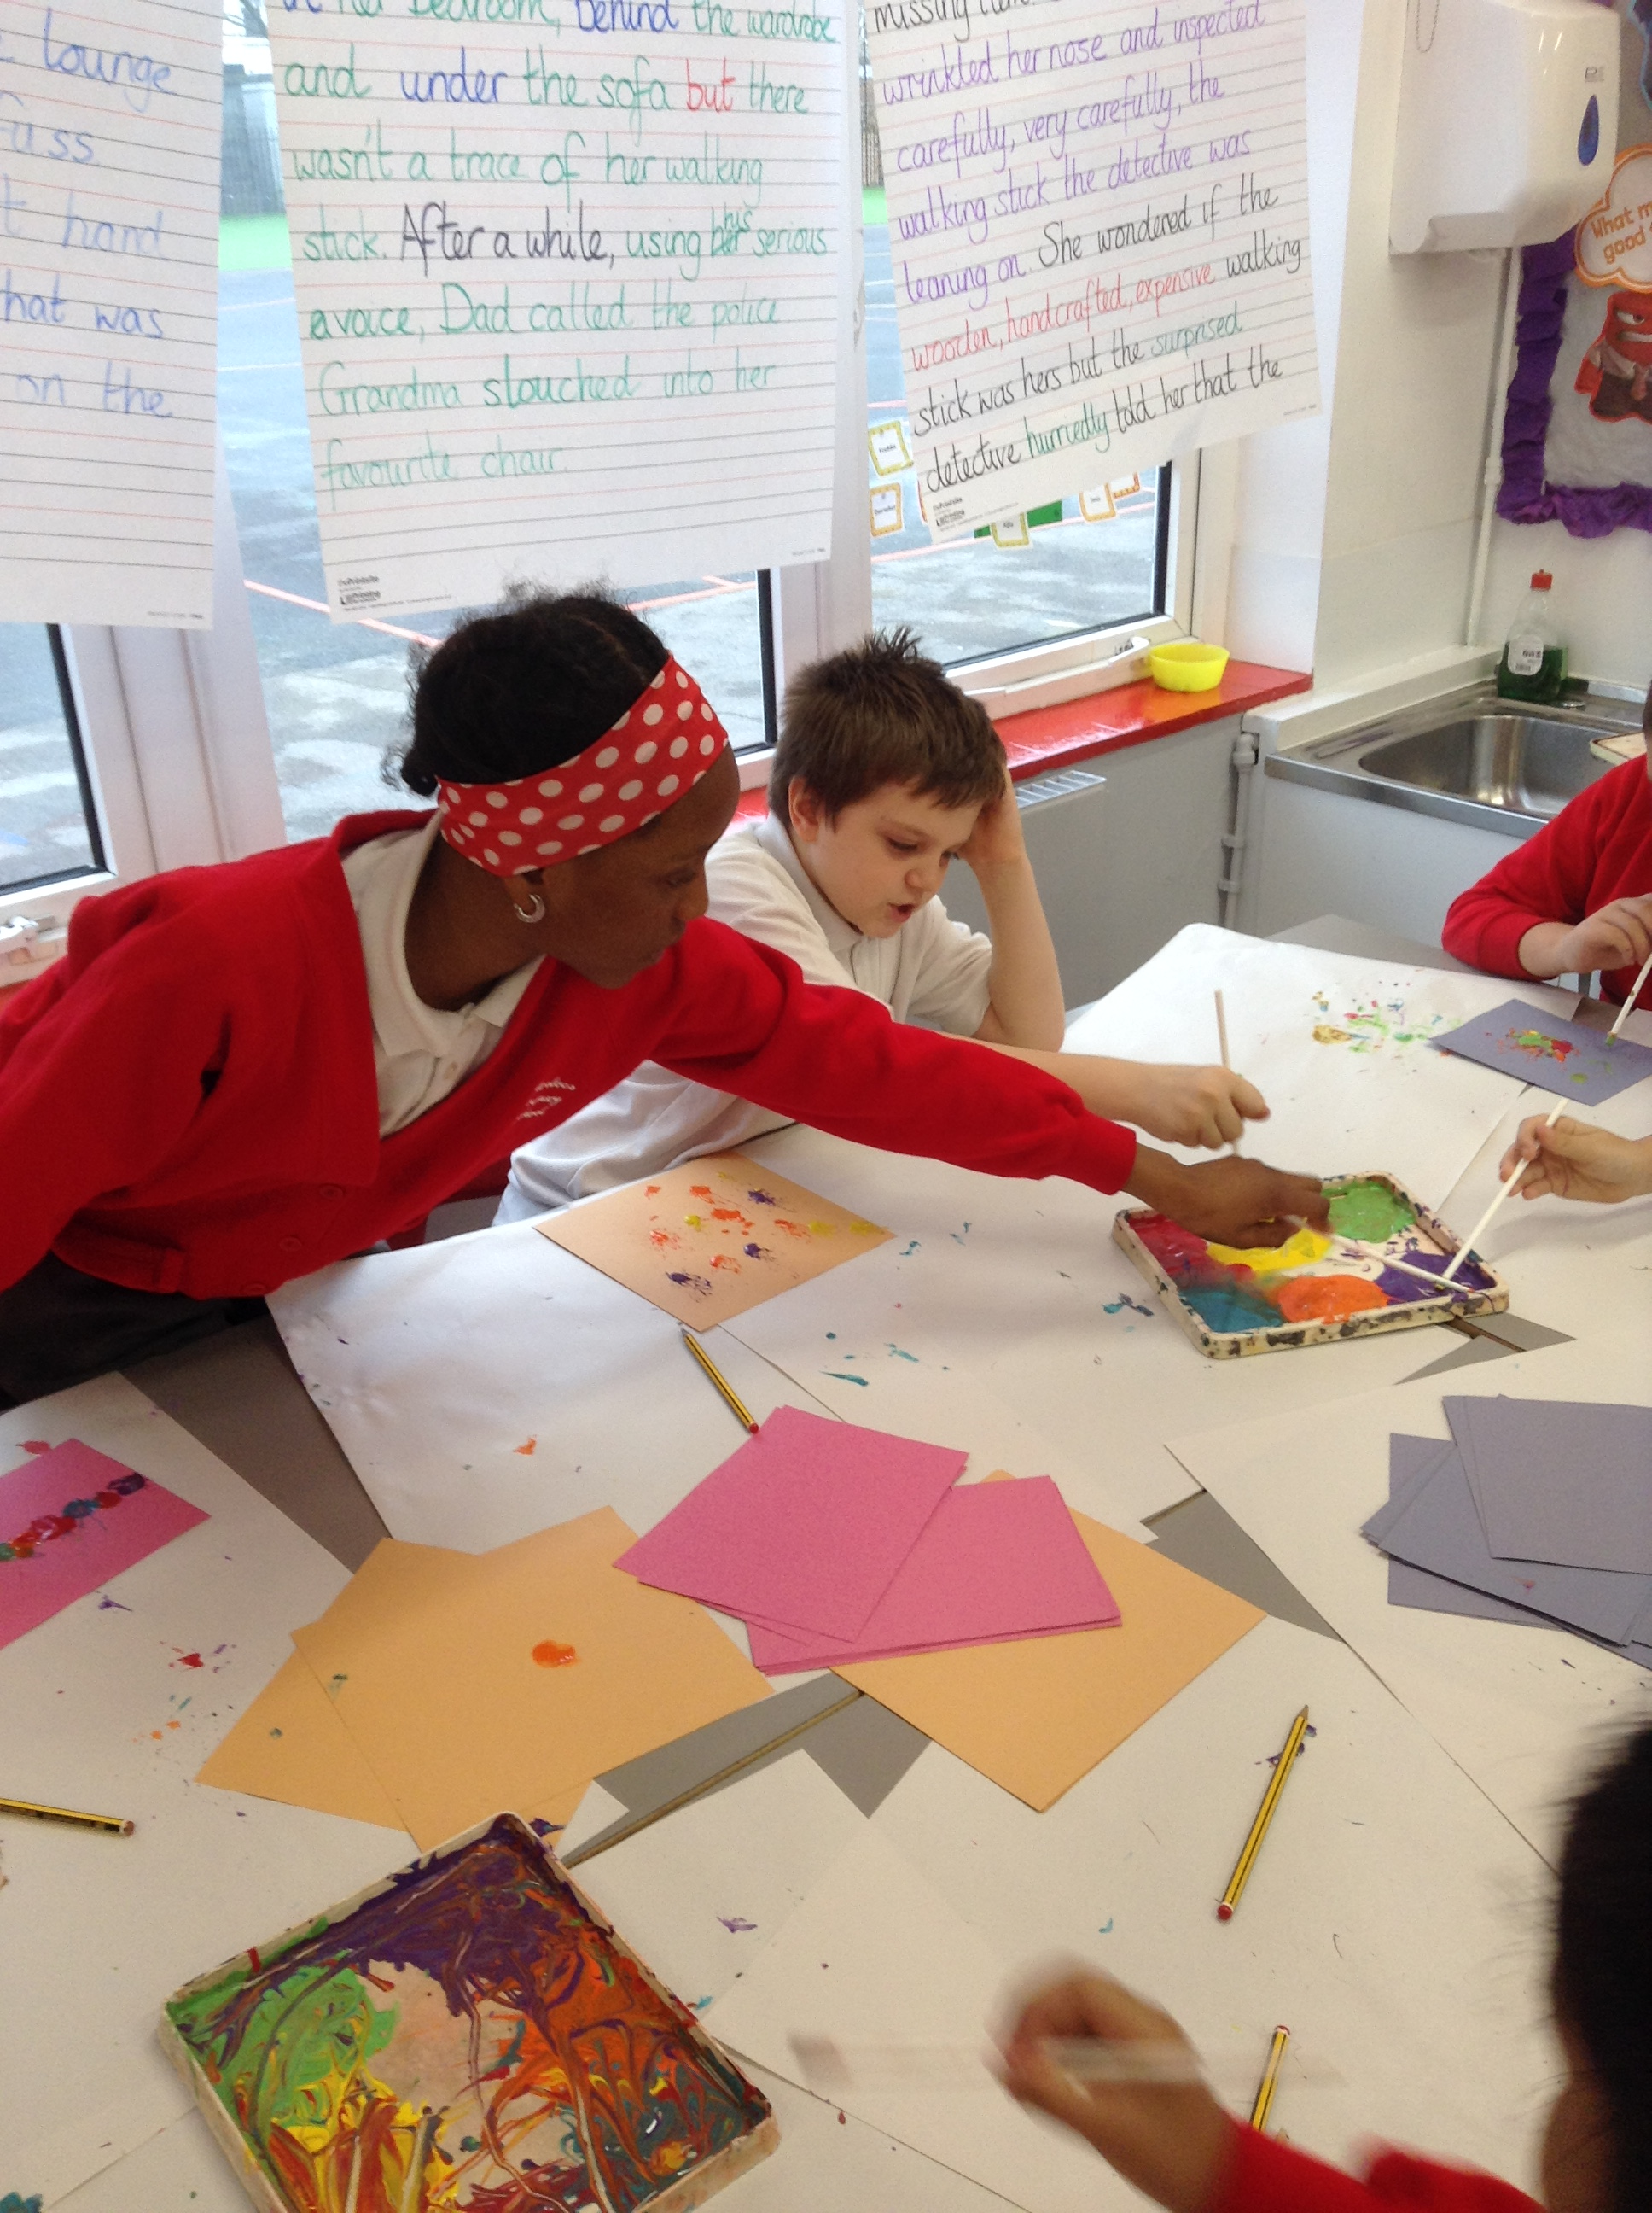

On Friday 31st January, the whole school in their houses completed activities to do with the brain. We learned about the prefrontal cortex, the amygdala and the hippocampus. The hippocampus is the elephant, the amygdala is the guard dog and finally the prefrontal cortex is the owl. Some of us did blow painting in Bannister house to relax our amygdala. Pankhurst house enjoyed peaceful yoga. Shakespeare house practised mindful colouring. Zach from Beech class said “It was interesting and fantastic!”. Mrs Morrissey told us that she loved the calm and relaxing music.

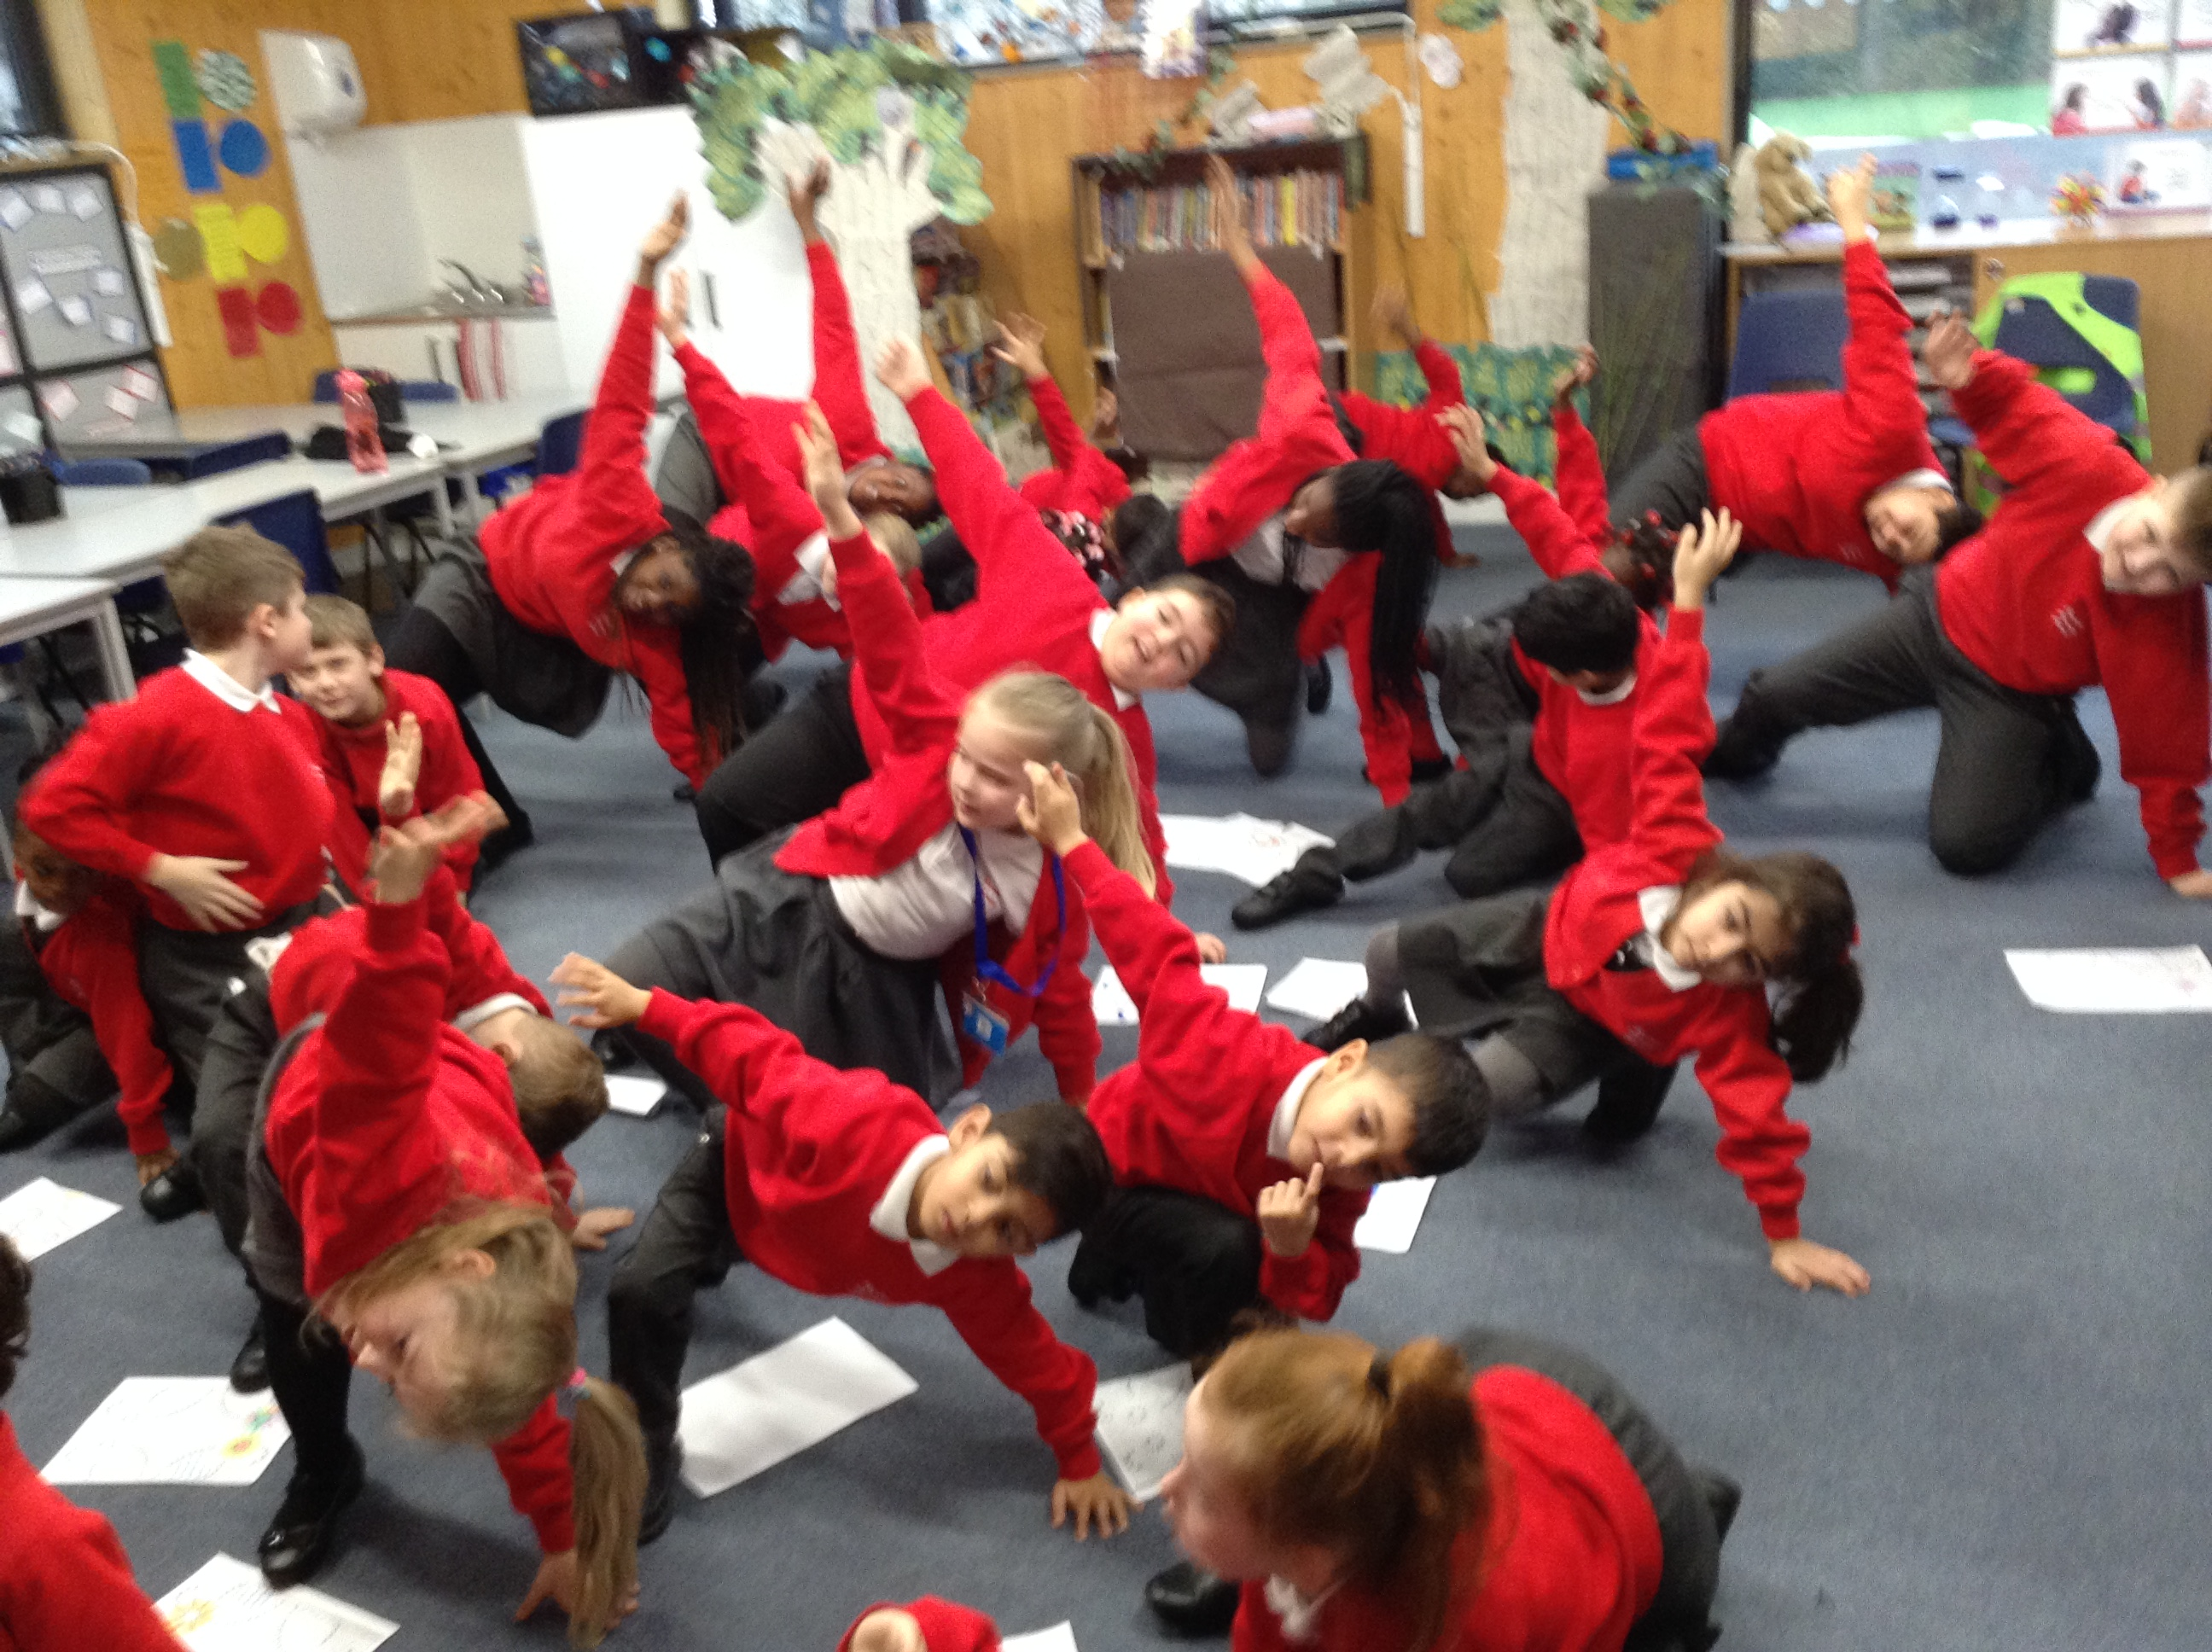

By Taira and Delight

Hello and welcome to the first edition of Parsloes Press. We hope you enjoy it!

**Year 5 Trip**

Last week, the Year Fives went to the science museum to learn more about space. During this trip ,they experienced lots of amazing activities and got to watch a movie with 3D glasses. There were also the crazy mirrors where they got to put their faces in and make them look silly! Ioana from Hummingbird said “It was really fun and I enjoyed the activities.” Lexi and Shaniyah shared that they learned a lot about space on the trip.

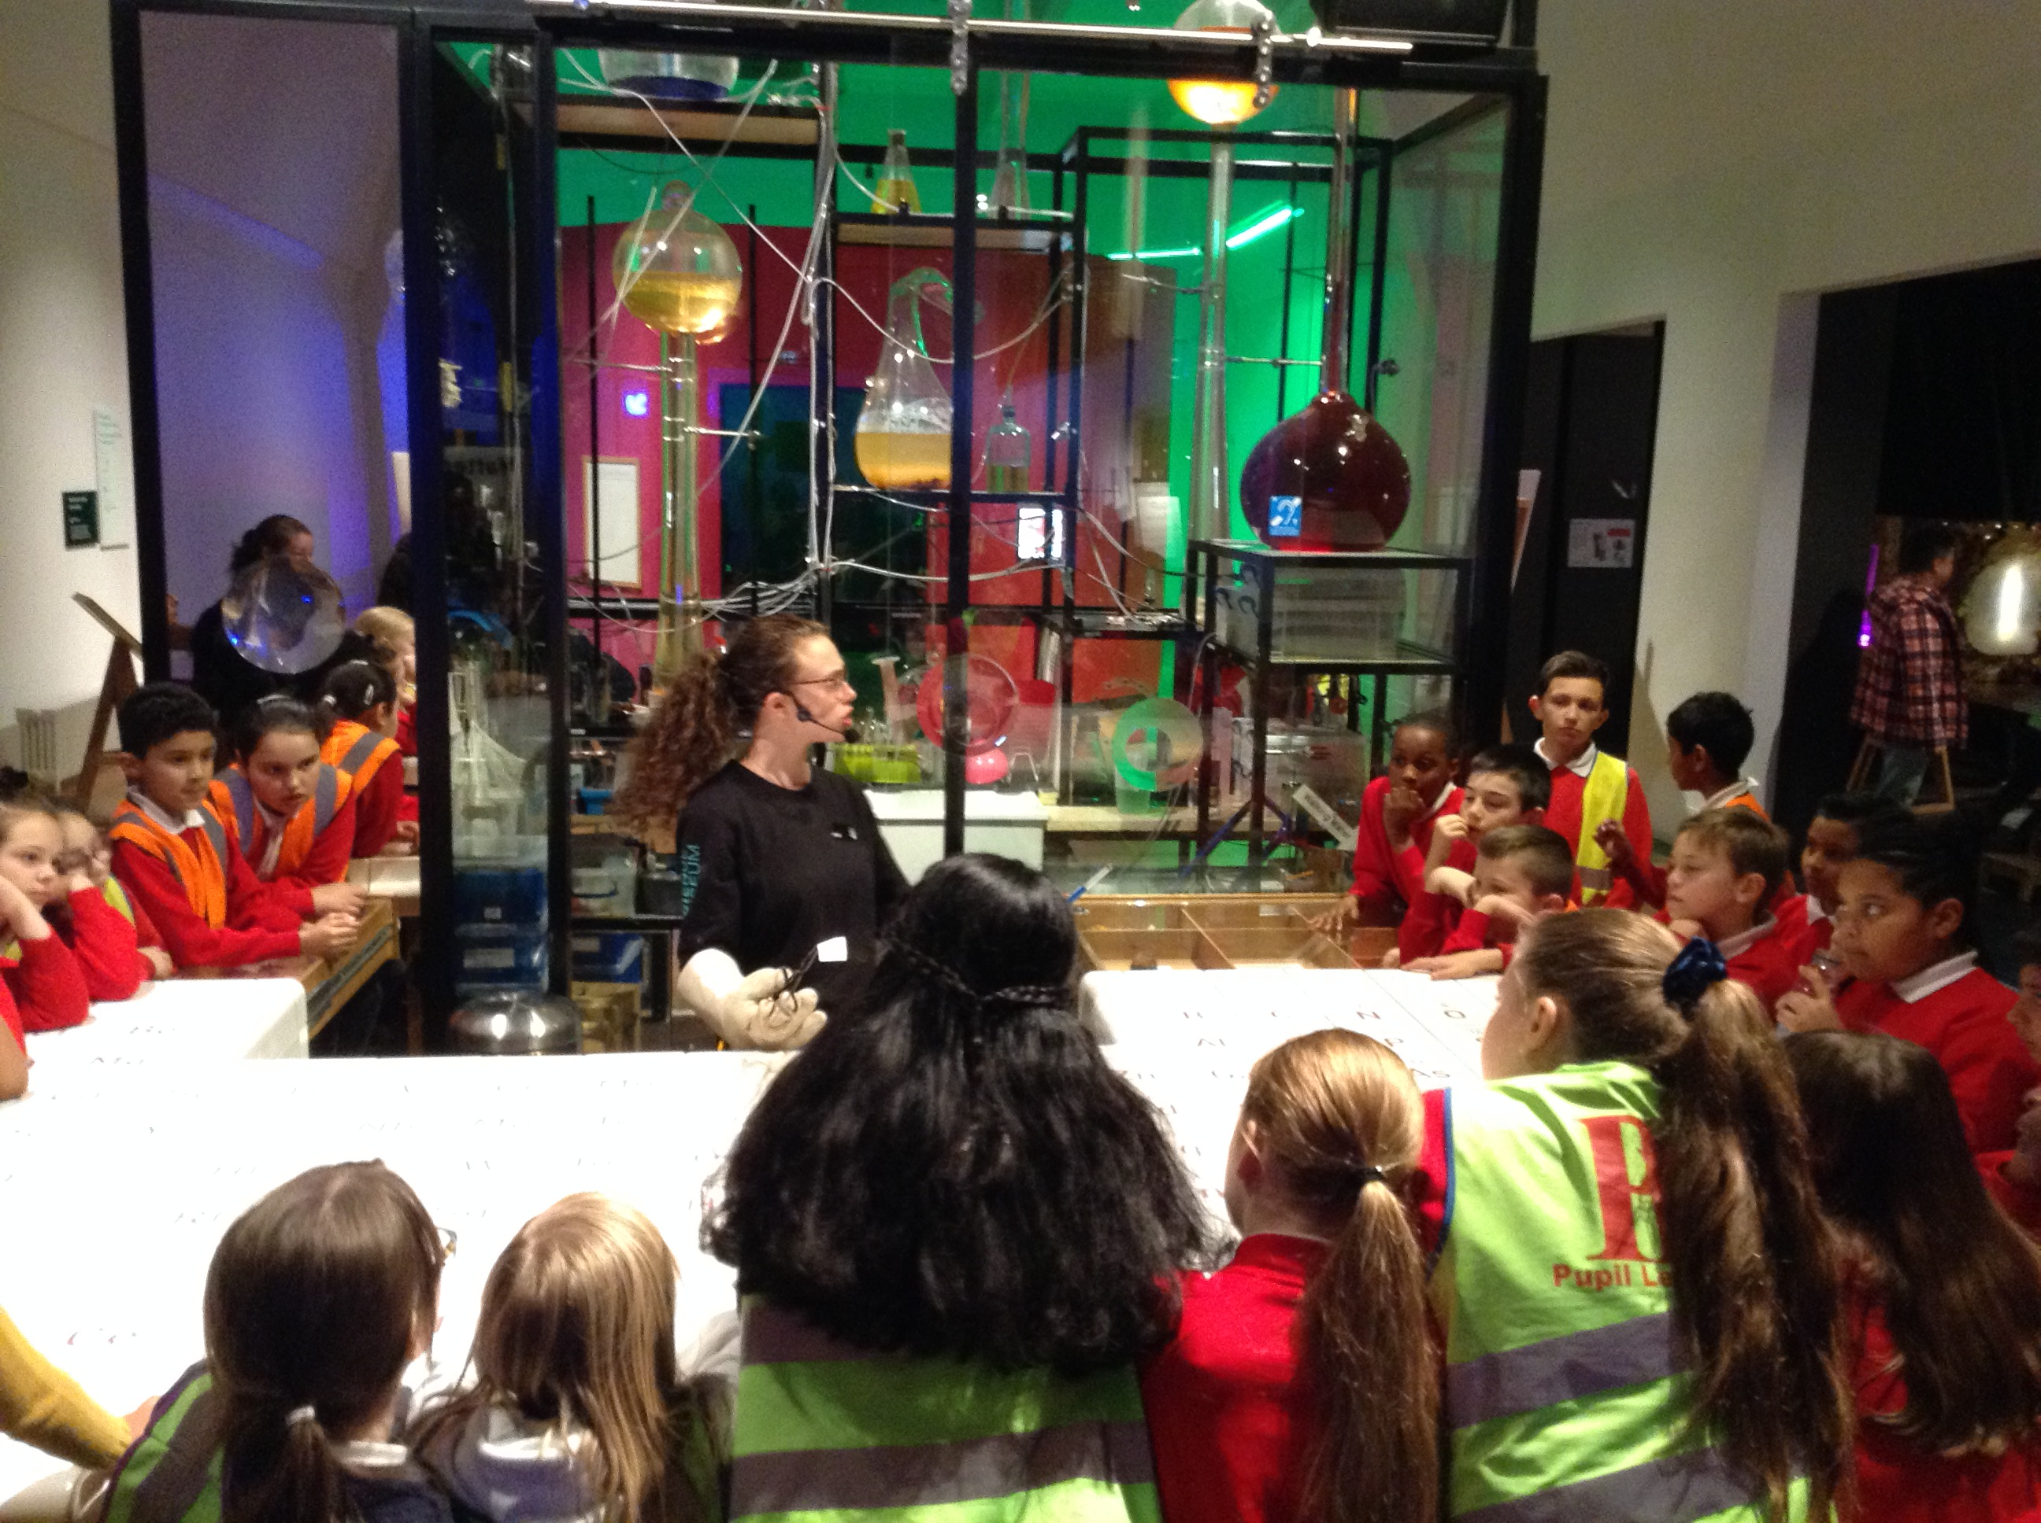

By Esther, Summer, Faith, Clara and Rida.

**School Updates**

Mrs Basri has a special visitor coming on Friday the 7th of February 2020 about a special award. Watch this space for more information!

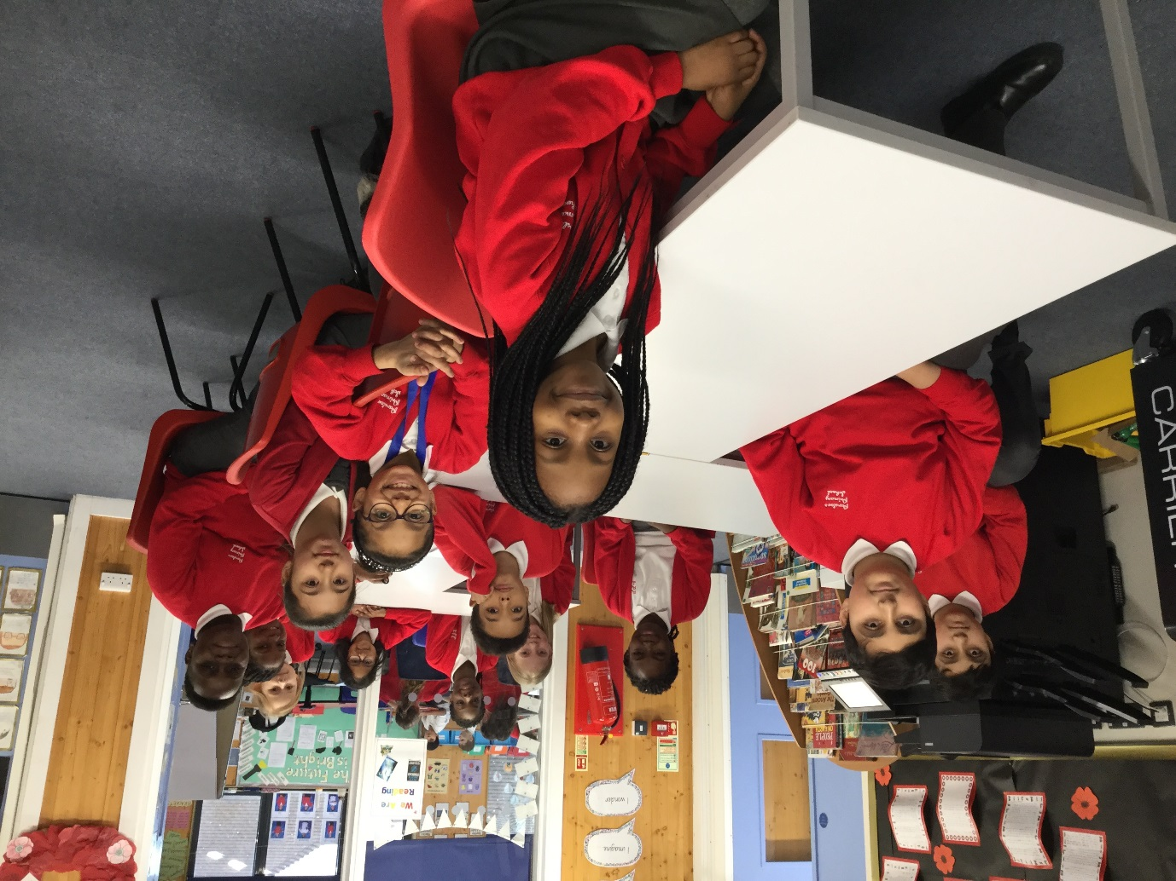

We hope you enjoyed the first edition of our school newspaper. If you have any ideas about what you would like to see in the newspaper, you can speak to anyone on the team.

**Riddle by Beatrice**

I travel all over the world yet I stay in a corner.

What am I? 

Answer: a stamp

**Did You Know…..**

Did you know that Mrs Ahmed loves cooking and gardening?

**The Daily Mile**

The Daily Mile is our school challenge to encourage students to become fit and healthy. The class ambassadors had to keep track of times their class have been outside and enjoying the fresh air.

Mr Asiedu, the Year 6 teacher who suggested this challenge, has reported, “The Daily Mile is the daily requirement to keep us fit.”

Prince, Kestrel student, has stated that it gives him a breath of fresh air and time for him to exercise his legs after sitting down for a long time.

By Rhemson, Alfie, Eshan and Aryan

